1. Install VirtualBox/VMware Workstation with different flavors of linux or windows OS on top of windows7 or 8.
Aim: To Install Virtualbox / VMware Workstation with different flavours of linux or windows OS.
PROCEDURE:
- Download the Virtual box exe and click the exe file…and select next button.

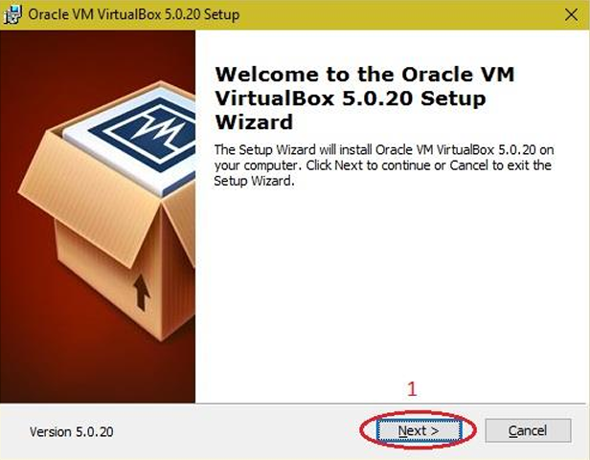

- Click the next button.
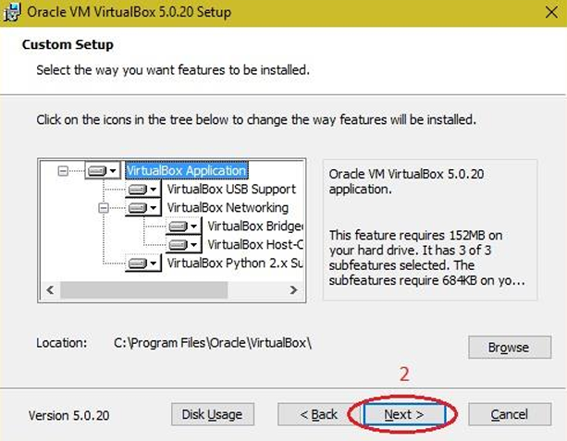

- Click the next button.
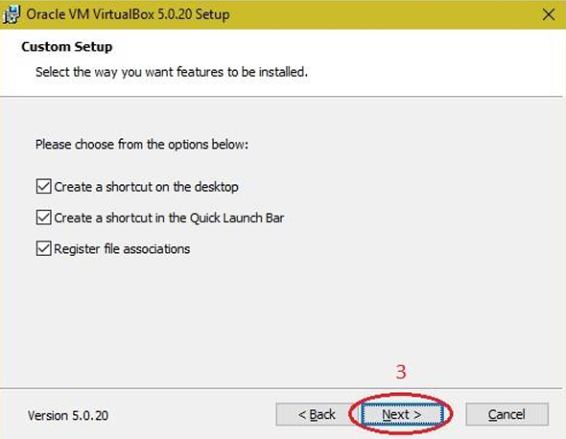

- Click the YES button.
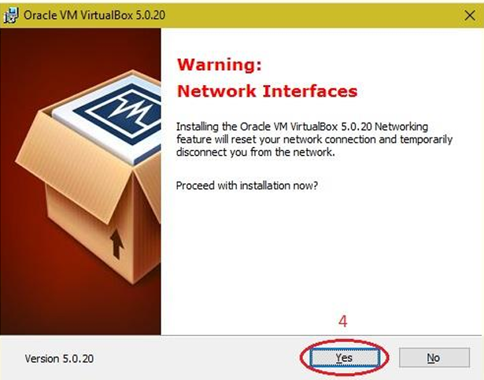

- Click the install button…
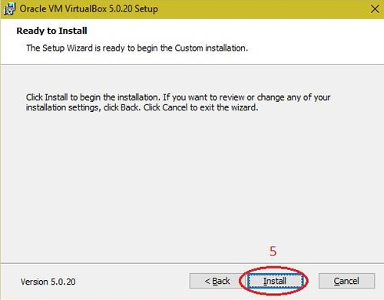

- Then installation was completed. The show virtual box icon on desktop screen….
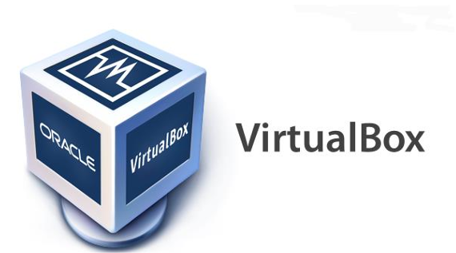

2. Install a C compiler in the virtual machine created using virtual box and executes Simple program.
Aim: To Install a C compiler in the virtual machine created using virtual box and executes Simple Program.
PROCEDURE:
Steps to import Ubuntu file
- Open Virtual box
- File ◊import Appliance
- Browse ubuntu_gt6.ova file
- Then go to setting, select USB and choose USB 1.1
- Then Start the ubuntu_gt6

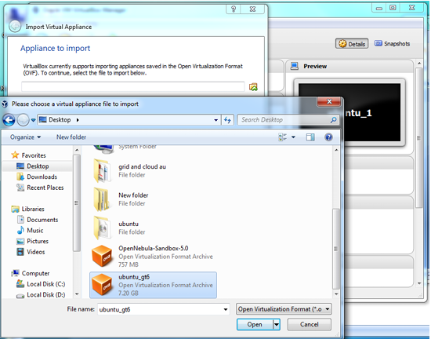

Steps to run C program:
1. Open the terminal
2. Type cd /opt/axis2/axis2-1.7.3/bin then press enter
3. gedit hello.c
4. gcc hello.c
5. ./a.out
Type gedit first.c
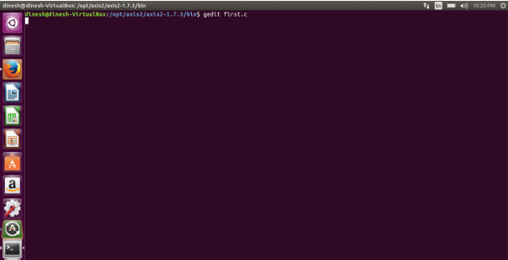

Type the C program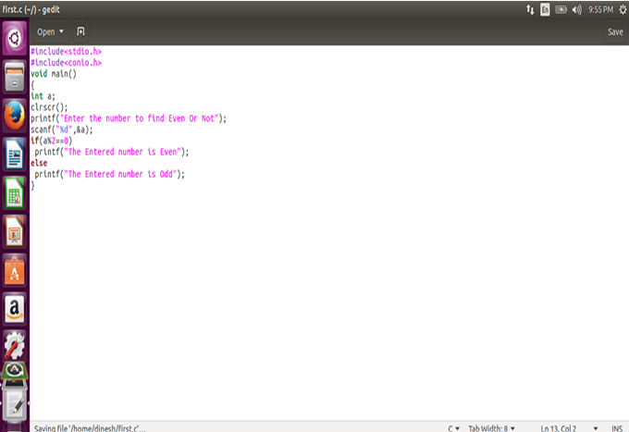

Running the C program
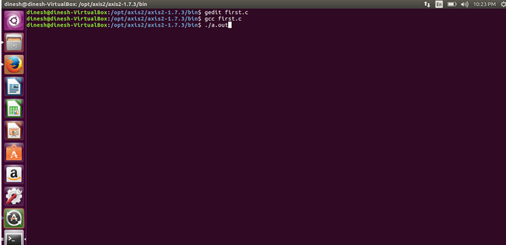

Display the output:
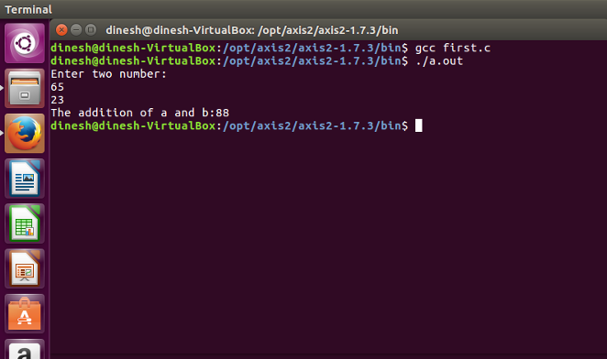

3. Create EC2 Instance in AWS (Amazon)
Aim: Create EC2 Instance in AWS (Amazon)
PROCEDURE:
The following are the steps for creating an EC2 instance in AWS (Amazon):
Step 1: First, log into your AWS account and click on “services” present on the left of the AWS management console, i.e. the primary screen. From the drop-down menu of options, tap on “EC2”. To create an AWS free tier account refer to Amazon Web Services (AWS) – Free Tier Account Set up.
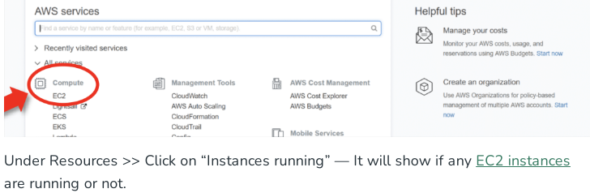

Step 2: Click on the launch instance click on the launch instance, after clicking on it you will be redirected to a launch page where we can create an instance. Configure all the requirements to Create a new instance like the name of the instance as shown in the figure below.

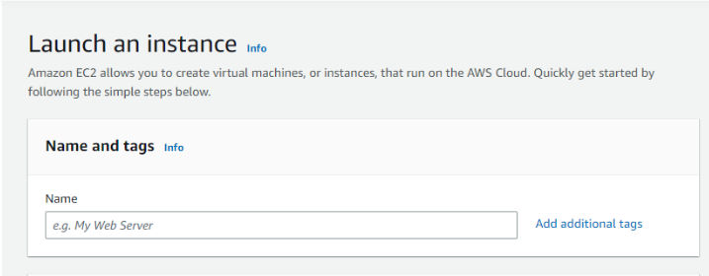
Step 3: Select AMI – Required operating system from the available. There are different types of OS available select the OS as per your requirement.
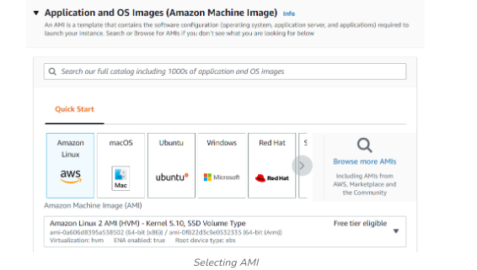

Step 4: By default, it selects a free tier of storage. (IF YOU ARE ELIGIBLE FOR THE FREE TIER). From the available storage specifications, select a free tier-eligible storage service. The instance type includes the number of CPUs required and the Memory required for your application. By default, the instance type is “t2.micro” which is a free tier-eligible service. Do not select any other which leads to the billing amount. To know more about instance types refer to Amazon EC2 – Instance Types.
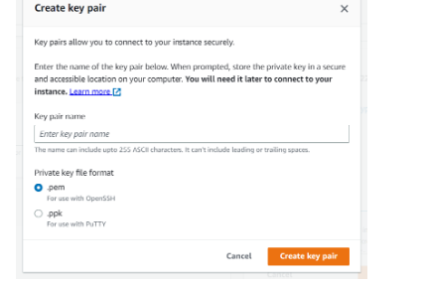

Step 5: Keep the network settings as default settings and make changes if required.StorageAs mentioned in the picture, Free tier eligible can get up to 30 GB of EBS Storage. Keep it as default.
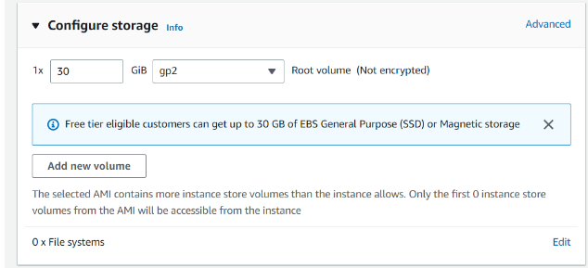

Step 6: Launching Instance At last, Check if all the selected are eligible for a free tier or not and click on “Launch instance”.That’s it, an instance will be created.

Steps To Connect Terminal Using SSH-Key:
Step 1: Select the server to which you want to connect and click on the connect button at the top of that instance as shown in the image below.

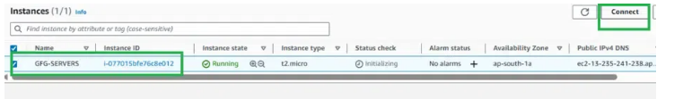

Step 2: Copy the SSH key which is right following the example it will acct as a key-pair to connect to EC2-Instance.
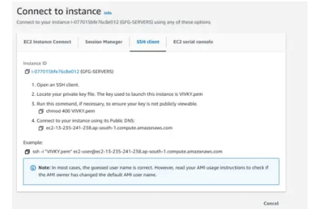
Step 3: Open the terminal and go to the folder where your .pem file is located and paste the key that you have copied in AWS and paste it in the terminal.
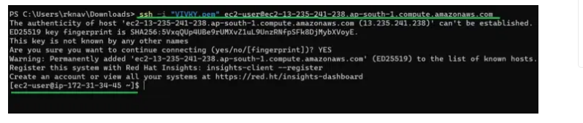

4. Develop a simple applications using Apex programming language of salesforce.com
Aim: To develop a simple custom application using the Apex programming language on the Salesforce cloud platform.

PROCEDURE:
Step 1: Sign up for a Salesforce Developer Org: If you don't have one, sign up for a free developer account on the Salesforce Signup Page.
Step 2: Log in to your Developer Org: Access your Salesforce instance with your credentials.
Step 3: Open the Developer Console: Click the gear icon (Setup) in the top-right corner of the Salesforce Classic interface or the top-left in Lightning Experience, and then select Developer Console.
Step 4: Create a New Apex Class:
- In the Developer Console, navigate to File > New > Apex Class.
- Enter a name for your class (e.g., HelloWorldApp) and click OK.
Step 5: Write the Apex Code: A basic class structure will be automatically generated. Add a method within the curly braces to perform a simple action, such as printing a message to the debug log.
Apex Code
public class HelloWorldApp {
public static void sayHello() {
System.debug('WELCOME TO APEX PROGRAMMING');
}
}
Ensure you click File > Save to save your new class.

Step 6: Execute the Apex Code:
- In the Developer Console, click the Debug menu and select Open Execute Anonymous Window.
- In the window that opens, enter the following code to call your method:
Apex Code
HelloWorldApp.sayHello();
- Ensure the Open Log checkbox is selected and click the Execute button.
Step 7: View the Output: The execution log will open automatically. To see only your output, ensure the Debug Only checkbox is selected in the log inspector. Your message "WELCOME TO APEX PROGRAMMING" will be displayed in the log.

5. Implement a mailing service using Apex programming language of salesforce.com
Aim: Implement a mailing service using Apex programming language of salesforce.com
Procedure:
Step 1: Open the Developer Console To open the Developer Console, you can either click on “Your Name” or the quick access menu (Setup gear icon) on the top right corner of the Salesforce page.
Step 2: Create a new Apex class In the Developer Console, click on “File” and then “New” and select “Apex Class”. Enter “EmailManager” as the class name and then click “OK”.
Step 3: Replace the default class body Replace the default class body with the following example of the EmailManager class.
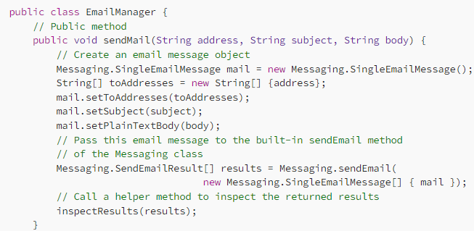
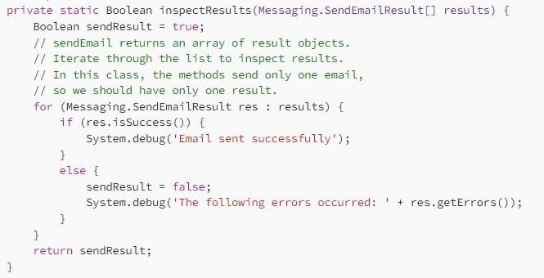
Step 4: Save the class Click on “File” and then “Save” to save your class. Once saved, you can use this class to send emails in other Apex classes or triggers.

Step 6: Test the output
- In the Developer Console, click Debug | Open Execute Anonymous Window.
- In the window that opens, enter the following. Replace ‘Your email addresses with your email address.
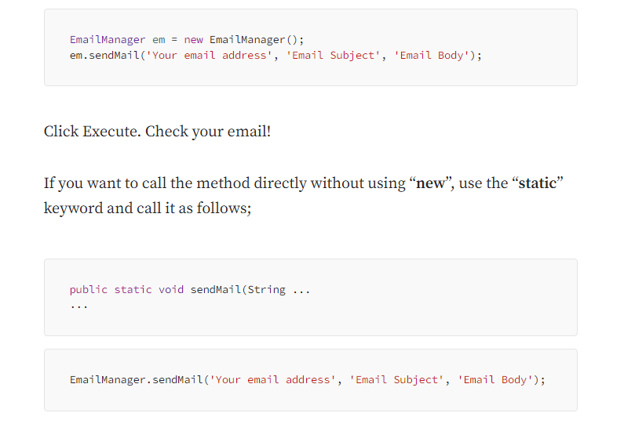
6. Simulate a cloud scenario using CloudSim and run a scheduling algorithm that is not present in CloudSim.
Aim: To Simulate a cloud scenario using CloudSim and run a scheduling algorithm that is not present in Cloud Sim.
PROCEDURE:
To use CloudSim in Eclipse:
Step 1: Download CloudSim installable files from
https://code.google.com/p/cloudsim/downloads/list and unzip
Step 2: Open Eclipse
Step 3: Create a new Java Project: File ->New
Step 4: Import an unpacked CloudSim project into the new Java Project
Step 5: The first step is to initialize the CloudSim package by initializing the CloudSim library as follows:
CloudSim.init(num_user, calendar, trace_flag)
Step 6: Data centres are the resource providers in CloudSim; hence, creation of data centres is a second step. To create Datacenter, you need the Data center Characteristics object that stores the properties of a data centre such as architecture, OS, list of machines, allocation policy that covers the time or space shared, the time zone and its price:
Datacenter data center 9883 = new Datacenter(name, characteristics, new Vm Allocation Policy Simple(host List)
Step 7: The third step is to create abroker:
DatacenterBroker broker = createBroker();
Step 8: The fourth step is to create one virtual machine unique ID of the VM, userId ID of the VM‟s owner, mips, number of Pes amount of CPUs, amount of RAM, amount of bandwidth, amount of storage, virtual machine monitor, and cloud let Scheduler policy for cloudlets:
Vm vm = new Vm(vmid, brokerId, mips, pesNumber, ram, bw, size, vmm, new
CloudletSchedulerTimeShared())
Step 9: Submit the VM list to the broker: broker.submitVmList(vmlist)
Step 10: Create a cloudlet with length, file size, output size, and utilisationmodel:
Cloudlet cloudlet = new Cloudlet(id, length, pesNumber, fileSize, outputSize, utilizationModel, utilizationMode
Step 11: Submit the cloudlet list to the broker: broker.submitCloudletList(cloudletList)
Step 12: Start the simulation: CloudSim.startSimulation()
Sample Output from the Existing Example:
Starting
CloudSimExample1...
Initialising...
Starting CloudSim version 3.0 Datacenter_0 is starting...
>>>>>>>>>>>>>>>>>>>>>>>>>>>>>>>>null
Broker is
starting...
Entities started.
: Broker: Cloud Resource List received with
1resource(s) 0.0: Broker: Trying to Create VM #0
inDatacenter_0
: Broker: VM #0 has been created in Datacenter #2, Host#0
0.1: Broker: Sending cloudlet 0 to VM #0
400.1: Broker: Cloudlet 0 received
: Broker: All Cloudlets executed. Finishing....400.1: Broker:
Destroying VM#0
Broker is shutting down...
Simulation: No more future events
CloudInformationService: Notify all CloudSim entities for shutting down. Datacenter_0 is shutting down...
Broker is shutting down...
Simulation completed.
Simulation completed.
=========OUTPUT===========
Cloudlet ID STATUS Data center ID VM ID Time Start Time Finish Time
0 SUCCESS 20 400 0.1 400.1
*****Datacenter: Datacenter_0***** Userid Debt
3 35.6
CloudSimExample1 finished!

Implementation of thread based image processing application in Microsoft Azure
Aim: To implement thread based image processing application in Microsoft Azure
PROCEDURE:

Step 1: Create Azure Account
- Go to Microsoft Azure
- Sign in or create a new account
- Open Azure Portal

Step 2: Create Storage Account
- In Azure Portal, search for Storage Accounts
- Click Create
- Fill details:
  - Resource Group: Create new
  - Storage Account Name: imagestorage123
  - Region: Choose nearest (e.g., Central India)
- Click Review + Create → Create

Step 3: Create Blob Container
- Open the created Storage Account
- Go to Containers
- Click + Container
- Name: images
- Access level: Private
- Click Create

Step 4: Upload Sample Images
- Open the images container
- Click Upload
- Select multiple image files
- Click Upload

Step 5: Get Connection String
- Go to Access Keys in Storage Account
- Copy Connection String
- Save it for use in code

Step 6: Install Required Libraries
Run the following in your system:
pip install azure-storage-blob pillow

Step 7: Write Multithreaded Python Code
import threading
from azure.storage.blob import BlobServiceClient
from PIL import Image
import io
# Azure connection
connection_string = "YOUR_CONNECTION_STRING"
container_name = "images"
blob_service_client = BlobServiceClient.from_connection_string(connection_string)
def process_image(blob_name):
blob_client = blob_service_client.get_blob_client(container=container_name, blob=blob_name)
# Download image
data = blob_client.download_blob().readall()
stream = io.BytesIO(data)
# Open and process image
img = Image.open(stream)
img = img.resize((200, 200)) # Resize
# Save processed image
output = io.BytesIO()
img.save(output, format='JPEG')
output.seek(0)
# Upload processed image
new_name = "processed_" + blob_name
blob_service_client.get_blob_client(container=container_name, blob=new_name).upload_blob(output, overwrite=True)
def main():
container_client = blob_service_client.get_container_client(container_name)
blobs = container_client.list_blobs()
threads = []
# Create threads
for blob in blobs:
t = threading.Thread(target=process_image, args=(blob.name,))
threads.append(t)
t.start()
# Wait for completion
for t in threads:
t.join()
print("All images processed successfully")
if __name__ == "__main__":
main()

Step 8: Run the Application
- Replace "YOUR_CONNECTION_STRING" with actual value
- Run the script: python app.py

Step 9: Verify Output
- Go back to Azure Portal
- Open Blob Container (images)
- Check for new files:
  - processed_image1.jpg
  - processed_image2.jpg

8. Deploy dynamic web application on EC2 Instance on AWS
Aim: To deploy dynamic web application on EC2 Instance on AWS
PROCEDURE:

Step 1: Launch an instance

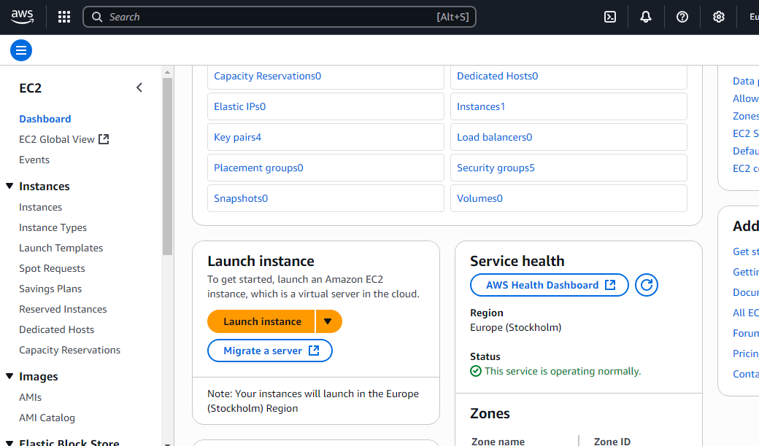

Type EC2 in search box, Click on EC2 , Later EC2 page will open as shown above Click on Launch instance

Step 2: Name and tags

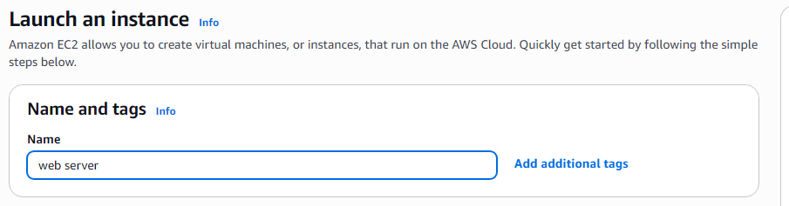
Under Name and tags give any Name like web server

Step 3: Under Application and OS images select Amazon Linux AWS

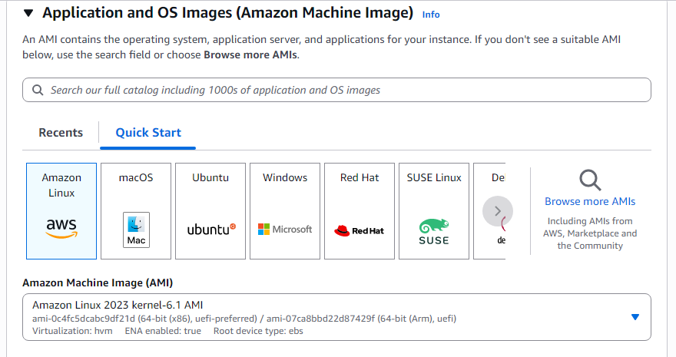

Step 4: Under Instant type select t3.micro

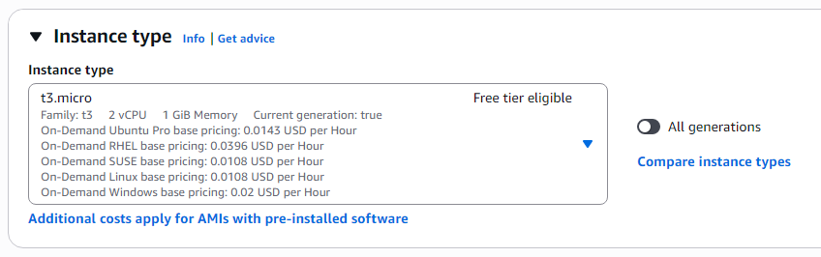

Step 5: Under Key Pair click on create new key Pair and give name to key Pair like kyp and click on create key pair, kyp.pm file will be downloaded.

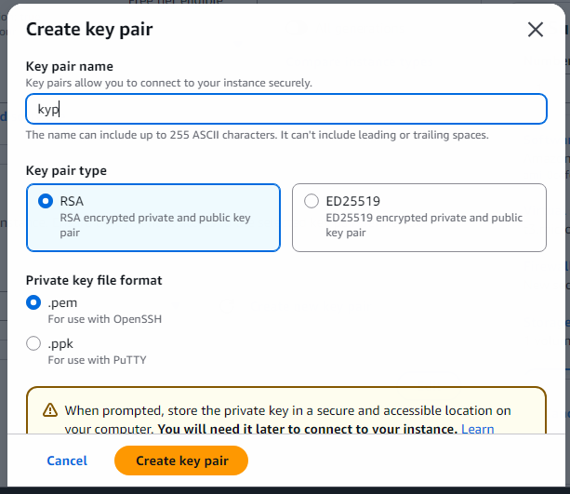

In network settings make sure allow SSH traffic from is enabled, and enable by clicking the check box of allow HTTPS traffic from internet and check box of allow HTTP traffic from internet

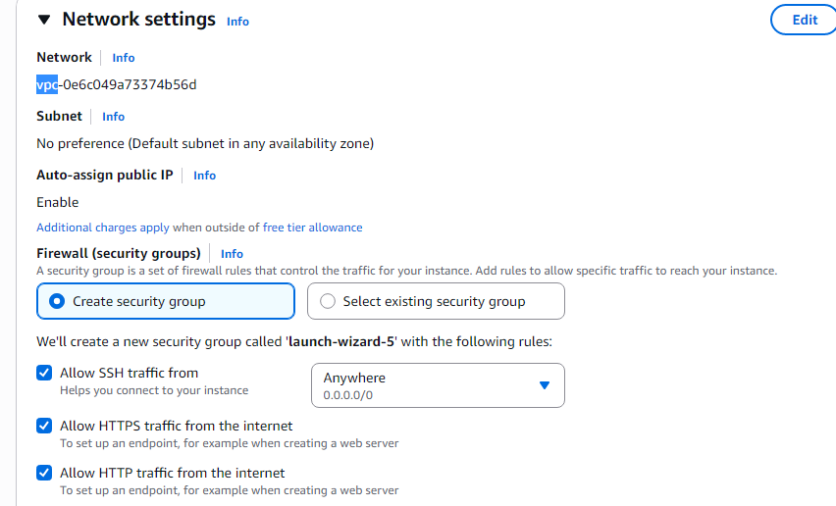
In Configure Storage keep as it is

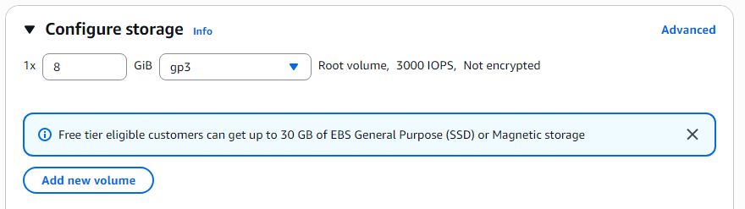

In Advanced details keep as it is.

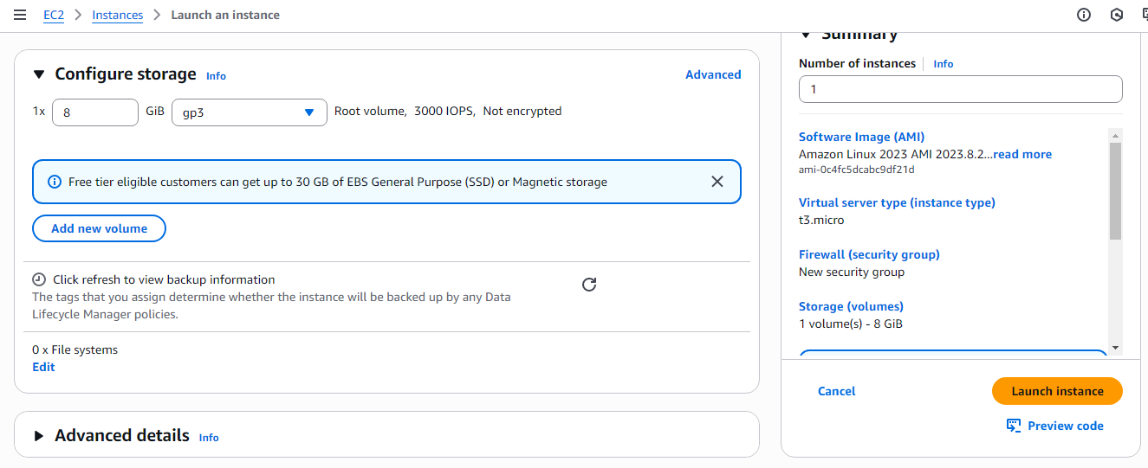

Again click on Launch Instance

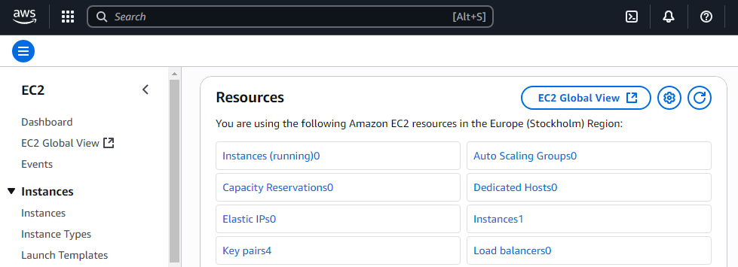
Affter Successful Launching click on Instances

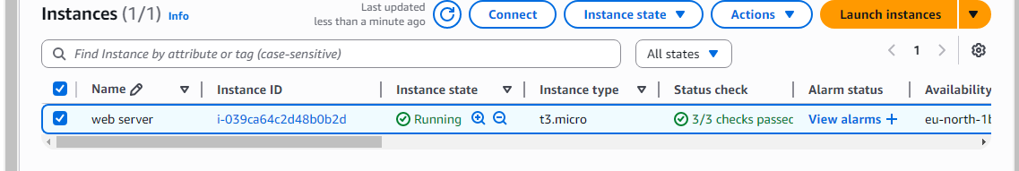

Select the check box of newly selected instance named web- server click on connect button

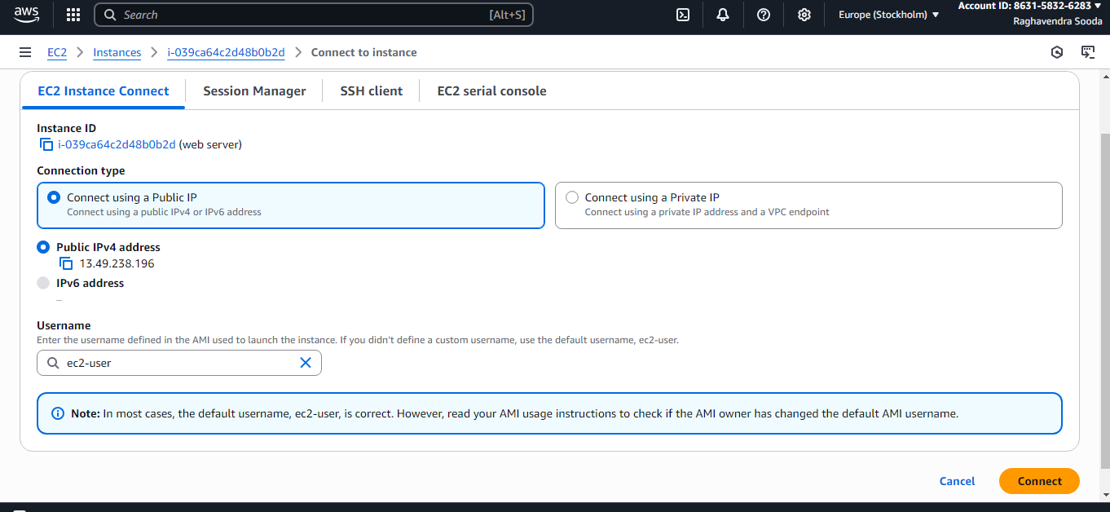

Under Connect select EC2 Instance Connect method and then press connect button.

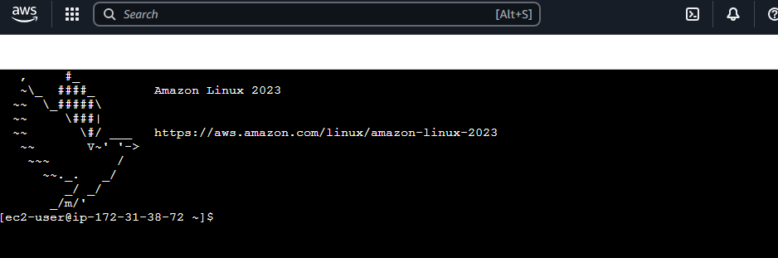
Type following steps
sudo su - ;root user yum update -y :update
yum install -y httpd ; install httpd server mkdir temp
cd temp
wget https://templatemo.com/download/templatemo_596_electric_xtra ;download website template files
ls -lrt
mkdir templatemo_596_electric_xtra_unzipped
unzip templatemo_596_electric_xtra -d templatemo_596_electric_xtra_unzipped cd templatemo_596_electric_xtra_unzipped
ls -lrt
cd templatemo_596_electric_xtra ls -lrt
mv * /var/www/html/ copy the extracte file /var/www/html cd /var/www/html/
ls -lrt
systemctl status httpd ; to check the status of httpd systemctl enable httpd ;enable the httpd server systemctl start httpd ; start the httpd server

click on the instances
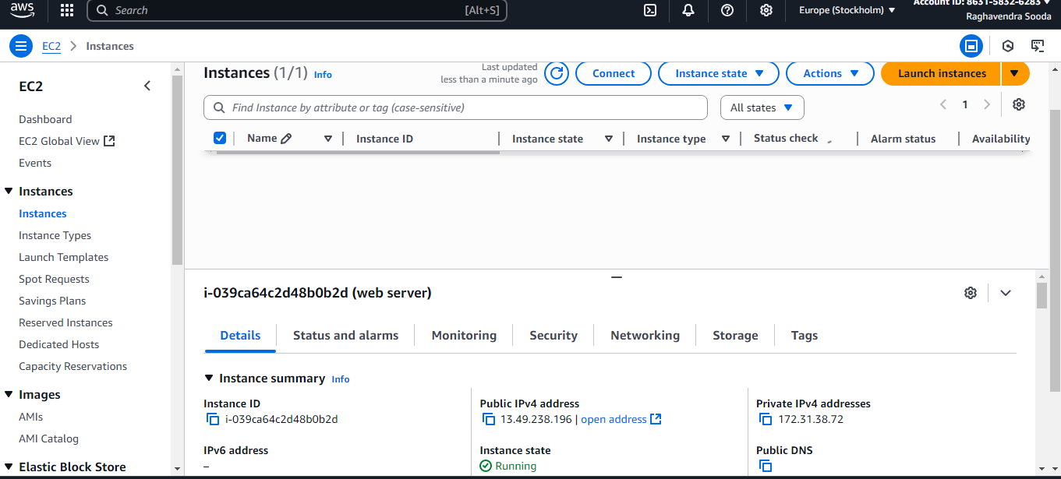

copy the public ipv4 address 13.49.238.1969 (in my case ) go to browser window paste the copied public ip of the instance. Web page will open as shown below

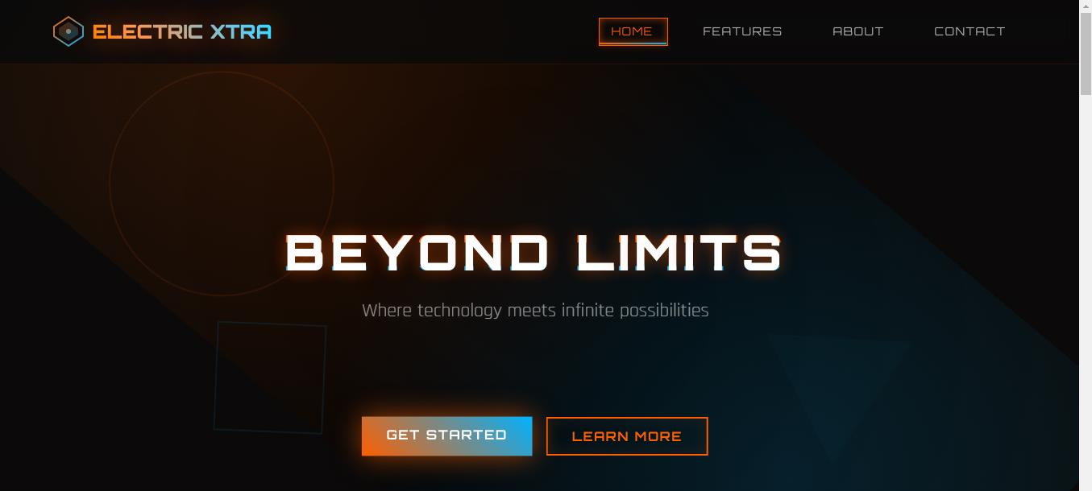

9. Use Google App Engine Launcher to launch web applications.
Aim: To use Google App Engine Launcher to launch web applications.
PROCEDURE:
C:\Documents and Settings\csev\Desktop\apps And then make a sub--‐folder in within apps called “ae--01--trivial” – the path to this folder would be: C:\ Documents and Settings \csev\Desktop\apps\ae--01--trivial Using a text editor such as JEdit (www.jedit.org)
create a file called app.yaml in the ae--01--trivial folder with the following contents: application: ae-01-trivial version: 1 runtime: python api_version: 1 handlers:- url: /.* script: index.py
Then create a file in the ae--01--trivial folder called index.py with three lines in it: print 'Content-Type: text/plain' print ' ' print 'Hello there Chuck'
Then start the GoogleAppEngineLauncher program that can be found under Applications. Use the File --> Add Existing Application command and navigate into the apps directory and select the ae--01--trivial folder.
Once you have added the application, select it so that you can control the application using the launcher.

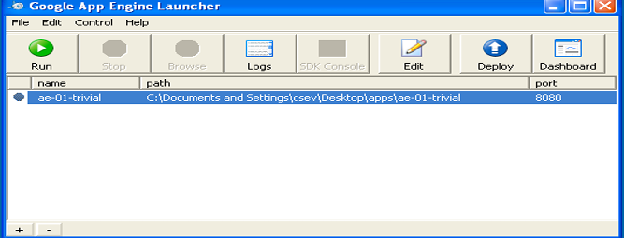

Once you have selected your application and press Run. After a few moments your application will start and the launcher will show a little green icon next to your application.
Then press Browse to open a browser pointing at your application which is running at http://localhost:8080/
Paste http://localhost:8080 into your browser and you should see your application as follows:

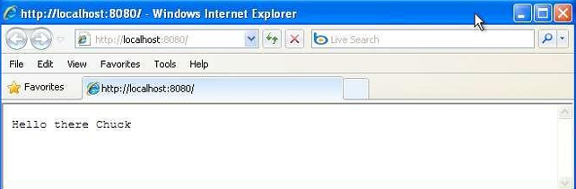

Edit the index.py to change the name “Chuck” to your own name and press Refresh in the browser to verify your updates.
Watching the Log You can watch the internal log of the actions that the web server is performing when you are interacting with your application in the browser.
Select your application in the Launcher and press the Logs button to bring up a log window:
Each time you press Refresh in your browser – you can see it retrieving the output with a GET request.
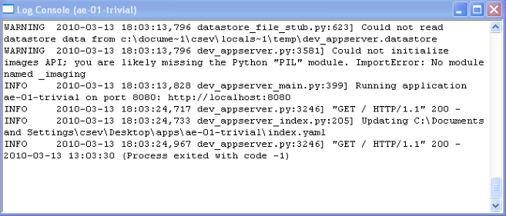
Dealing with Errors
With two files to edit, there are two general categories of errors that you may encounter. If you make a mistake on the app.yaml file, the App Engine will not start, and your launcher will show a yellow icon near your application:
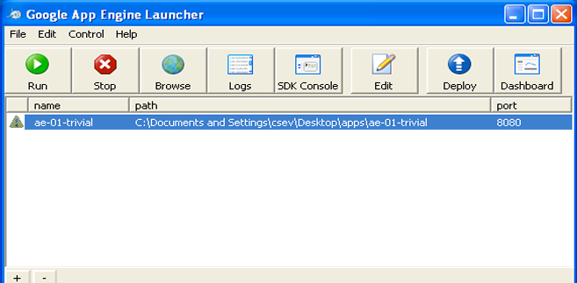
To get more detail on what is going wrong, take a look at the log for the application:
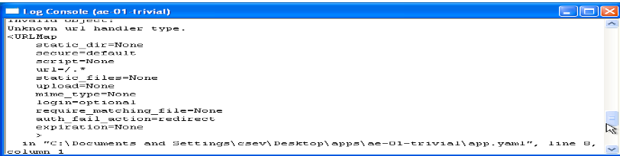
Result:
Thus the GAE web applications were created.

10. Deploy static web application using S3 on AWS and secure it with signed URL’s
Aim: To deploy static web application using S3 on AWS and secure it with signed URL’s
PROCEDURE:
Step 1: Create AWS S3 bucket:
- On AWS console move to S3 and create bucket,
- Select AWS region
- Enter the Bucket name
- Uncheck the "Block all public access"
- leave the rest of the settings default and press Create Bucket
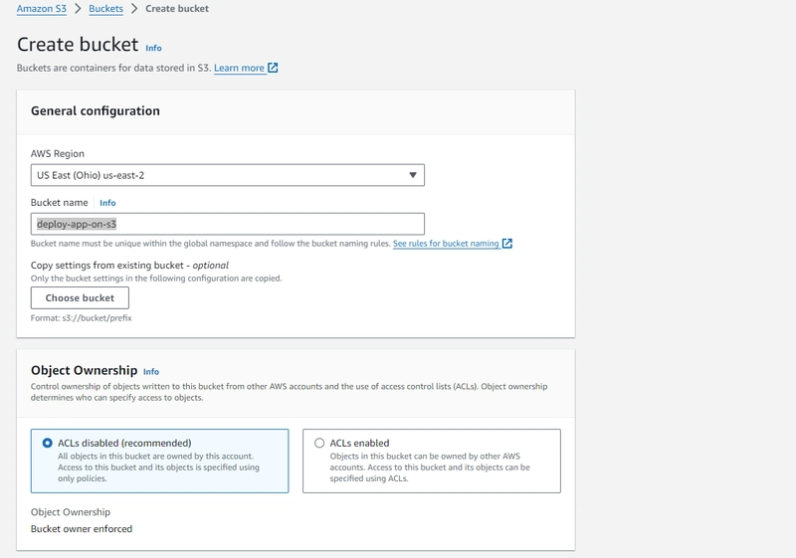
Step 2: Once it is created then select "Properties", scroll down to bottom, "Edit" the static website hosting and set the below settings and press "Save changes",

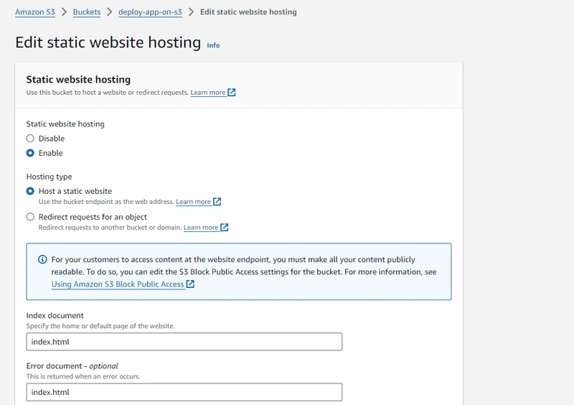
Step 3: Then, select "Permissions", then "Edit" the Bucket policy, add the following content (remember to update the BUCKET_NAME) and Save Changes,
{
"Version": "2012-10-17",
"Statement": [
{
"Sid": "PublicReadGetObject",
"Effect": "Allow",
"Principal": "*",
"Action": "s3:*",
"Resource": [
"arn:aws:s3:::BUCKET_NAME/*",
"arn:aws:s3:::BUCKET_NAME"
]
}
]
}
Step 4: Upload Your Files:
- Open your new bucket and click Upload.
- Drag and drop your website files (e.g., index.html, styles.css) and click Upload.

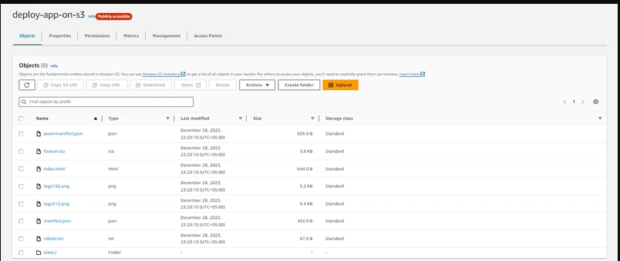
Now the static app will be accessible on the S3 static url,
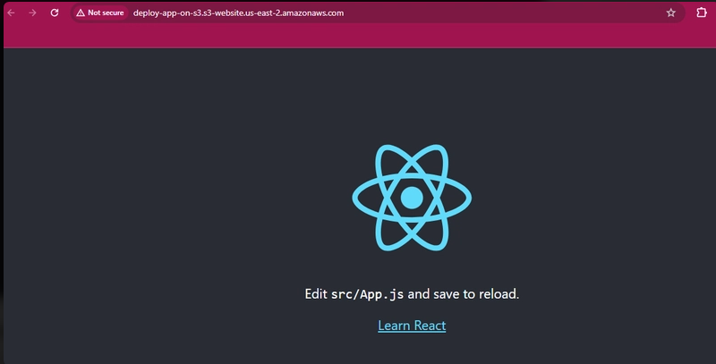
Step 5: Attach Cloudfront with S3:
To access the static content from S3 with high speed and less latency we will attach the cloudfront with S3 bucket. To do so,
- move to Cloudfront from AWS console. Press the "Create Distribution"
- Copy the static url from the s3 bucket properties and place it in the origin domain for cloudfront. Don't forget to remove the https:// from the s3 bucket static url.Image description
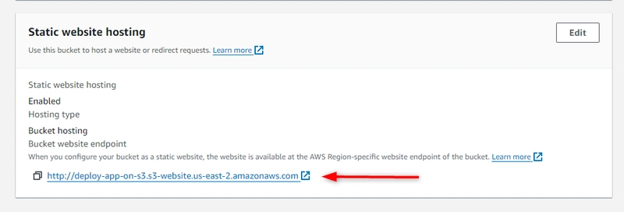
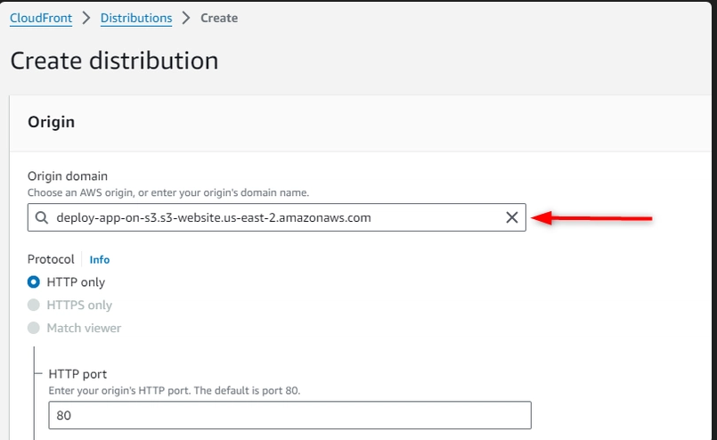
- Then, select the Redirect HTTP to HTTPS and set the Allowed HTTP methods:
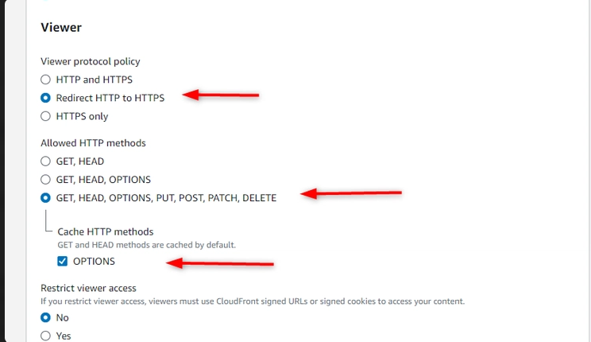
- Then press "Create Distribution"

- Once the distribution is created, you will be able to access your website on Distribution domain name:
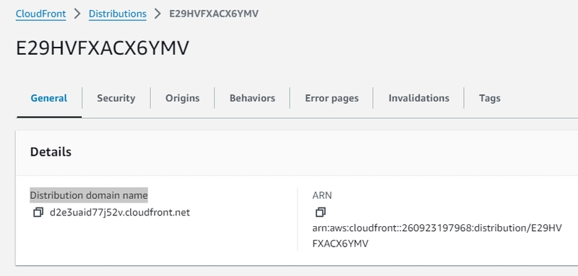
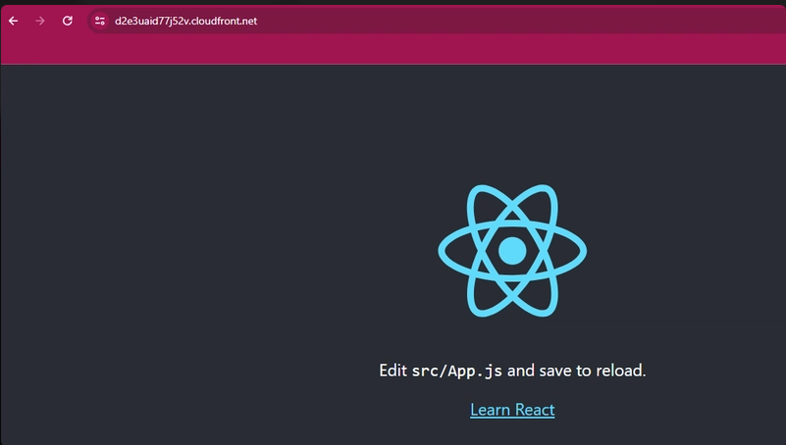

If you created your static website only as a learning exercise, delete the AWS resources that you allocated so that you no longer accrue charges. After you delete your AWS resources, your website is no longer available.

11. Create Video streaming service using S3 and cloudfront and AWS Elemental Media Convert Digital Rights Management System
Step 1: Set Up Your Amazon S3 Bucket
Storing raw video assets in a secure S3 bucket prevents unauthorized direct downloads while remaining available for your CDN.
- Login to AWS Management Console. Navigate to: Services → S3
- Click Create bucket.
- Enter a globally unique name (e.g., my-video-streaming-bucket-2026).
- Select your preferred AWS Region (e.g., us-east-1 or your closest localized region).
- Configure Settings:
- Block Public Access: Ensure Block all public access remains checked. Your bucket must remain private to force users through CloudFront.
- Bucket Versioning: Select Enable.
- Default Encryption: Select Enable with SSE-S3.
- Click the Create bucket button at the bottom.
- Upload a Video: Click on your new bucket name, select Upload, add a test .mp4 video, and finish by clicking Upload.
Step 2: Create a CloudFront Distribution
CloudFront acts as the CDN, which retrieves your private S3 objects securely and distributes them to your users.
- Search for and open the CloudFront console.
- Click Create distribution.
- Origin Settings:
- Origin domain: Select the S3 bucket you created in Step 1.
- Origin access: Select Origin access control settings (recommended).
- Origin access control (OAC): Click Create control setting, leave the default settings, and hit Create. (This securely connects CloudFront to your private S3 bucket).
- Default Cache Behavior Settings:
- Viewer protocol policy: Select Redirect HTTP to HTTPS.
- Allowed HTTP methods: Select GET, HEAD.
- Cache key and origin requests: Choose Cache policy and origin request policy (recommended) -> Cache policy: CachingOptimized.
- Web Application Firewall (Optional): Select Do not enable security protections (for basic lab purposes).
- Create Distribution: Click Create distribution at the bottom of the page.
Step 3: Update S3 Bucket Policy for CloudFront
Because your S3 bucket is private, you need to grant CloudFront permission to access the video files.
- Once your CloudFront distribution is created, a banner will appear at the top prompting you to Copy policy. Copy the policy JSON provided.
- Go back to your S3 console and click on your bucket.
- Select the Permissions tab.
- Scroll down to Bucket policy and click Edit.
- Paste the copied CloudFront policy into the editor and click Save changes.
Example:
{
"Version": "2012-10-17",
"Statement": [
{
"Sid": "AllowCloudFrontServicePrincipal",
"Effect": "Allow",
"Principal": {
"Service": "cloudfront.amazonaws.com"
},
"Action": "s3:GetObject",
"Resource": "arn:aws:s3:::video-streaming-bucket/*"
}
]
}
Step 4: Test Your Streaming Service
- Go back to your CloudFront distributions page and wait for the status to change from Deploying to Last modified (with a green checkmark).
- Copy the Distribution domain name (e.g., d111111abcdef8.cloudfront.net).
- Open a new web browser tab, paste the domain name, and append the name of the uploaded video file to the end of the URL (e.g., https://cloudfront.net).
- The video should load immediately in the browser via the CloudFront stream.

